**HOSPITAL MANAGEMENT SYSTEM**

**A Project Report Submitted in Partial Fulfilment of the requirements for the award of the Degree of**

**MASTER OF SCIENCE IN INFORMATION TECHNOLOGY**

Submitted by

**SIVA SHANMUGAM.N**

**(REGISTER NUMBER: 21MIT439)**

Under the Guidance of

**Dr.T.CHRISTOPHER M.Sc., M.C.A., M.Ed., M.Phil., Ph.D.,**

**Assistant Professor, Department of Information Technology**



**POST GRADUATE & RESEARCH DEPARTMENT OF INFORMATION TECHNOLOGY**

**GOVERNMENT ARTS COLLEGE (AUTONOMOUS)**

(Affiliated to Bharathiar University and Re-accredited with “B++” by NAAC)

**COIMBATORE-641 018**

**MAY-2023**

**POST GRADUATE & RESEARCH DEPARTMENT OF INFORMATION TECHNOLOGY**

**GOVERNMENT ARTS COLLEGE (AUTONOMOUS)**

(Affiliated to Bharathiar University and Re-accredited with “B++” by NAAC)

**COIMBATORE-641 018**

**CERTIFICATE**

This is to certify that the project “ **Hospital Management System ”** submitted in partial fulfilment of the requirement for the award of the Degree of Master of Science in Information Technology is a record of original work done By **Siva Shanmugam.N** under my supervision and guidance.

**HEAD OF THE DEPARTMENT SIGNATURE OF THE GUIDE**

Submitted for the Viva- Voce Examination held on 03-05-2023

**INTERNAL EXAMINER EXTERNAL EXAMINER**

**DECLARATION**

I hereby declare that this project work entitled, **“ Hospital Management System ”** Submitted to the Government Arts College(Autonomous), Coimbatore-18, in Partial fulfilment of the requirements for the award of the degree of Master of Science in Information Technology is a Bonafide Record of Original Project Work done by me under the Supervision and Guidance of **Dr.T.CHRISTOPHER M.Sc., M.C.A., M.Ed., M.Phil., Ph.D.,** Assistant Professor of Information Technology, Post Graduate and Research Department of Information Technology, Government Arts College(Autonomous) Coimbatore-18, Affiliated to Bharathiar University, Coimbatore-18 and this Project Work has not formed the basis for the award of any Degree/ Diploma/ Associate Ship. Fellowship or similar title to any candidate of any University.

**PLACE:** Coimbatore  **SIGNATURE OF THE CANDIDATE**

**DATE: SIVA SHANMUGAM.N**

**(Reg.no: 21MIT439)**

**ACKNOWLEDGEMENT**

It have been said that gratitude is the memory of heart. We would like to take this opportunity express our gratitude to all those, guidance and encouragement served as a light and crowed my efforts.

We will be ever grateful and thankful to **Dr.R.ULAGI M.Sc., M.Phil., Ph.D.,** Principal of our esteemed college for allowing us to do our project with her moral support.

We feel grateful to **Dr.B.LOGANATHAN M.C.A., M.Phil., Ph.D.,** Associate Professor and Head, Department of Information Technology, for providing us this opportunity and extending a constant monitoring throughout the course of the project.

We are pleased to thank **Dr.T.CHRISTOPHER M.Sc., M.C.A., M.Ed., M.Phil., Ph.D.,** Assistant Professor, Post Graduate & Research Department of Information Technology, for her valuable guidance and constant monitoring the course of the project.

Finally our heartfull thanks to all other faculty members, our parents, our Friends for their support without which we would not been able to complete this Project.

**TABLE OF THE CONTENTS**

ABSTRACT.............................................................................................. i

1. **INTRODUCTION**.................................................................................. 1

1.1.OVERVIEW OF THE PROJECT.................................................... 1

1. **SYSTEM SPECIFICATION**................................................................. 3
   1. HARDWARE SPECIFICATION................................................ 3
   2. SOFTWARE SPECIFICATION................................................. 4
      1. FRONT END........................................................... 4
      2. BACK END............................................................. 7
2. **SYSTEM STUDY AND ANALYSIS**.................................................... 8
   1. SYSTEM STUDY................................................................... 8
      1. FESABILITY STUDY.............................................. 8
   2. SYSTEM ANALYSIS............................................................. 10
      1. EXISTING SYSTEM............................................... 10
      2. PROPOSED SYSTEM............................................. 10
3. **SYSTEM DESIGN AND DEVELOPMENT**..................................... 12
   1. INPUT DESIGN................................................................... 12
   2. OUTPUT DESIGN................................................................. 13
   3. TABLE DESIGN................................................................... 14
   4. MODULE DESCRIPTION...................................................... 19
   5. DATAFLOW DIAGRAM...................................................... 21
   6. ER DIAGRAM...................................................................... 24
4. **SYSTEM TESTING**............................................................................. 26
5. **CONCLUSION**.................................................................................... 30

CONCLUSION......................................................................... 30

SCOPE OF FUTURE ENHANCEMENT...................................... 30

**BIBLIOGRAPHY**............................................................................. 32

**ANNEXURE**...................................................................................... 33

SCREEN SHORTS................................................................... 33

**ABSTRACT**

The purpose of the project entitled as “HOSPITAL MANAGEMENT SYSTEM” is to computerize the front office management of hospital to develop web application which is user friendly simple, fast, and cost–effective. It deals with the collection of patient’s information, doctor’s information, appointment details, diagnosis details, etc.

The patient can book their own appointment. Traditionally, it was done manually. The main function of the system is register and store patient details and doctor details and retrieve these details as and when required, and also to manipulate these details meaning fully system input contains patient details, diagnosis details, while system output is to get these details on to the screen.

The Hospital Management System can be entered using a username and password. It is accessible either by an administrator or receptionist. Only they can add doctor data into the database. The patient can register their own details. The data can be retrieved easily. the doctors can retrieved the patient’s details only. The data are well protected for personal use and makes the data processing very fast.

The proposed System consists of three Modules there are Admin Login , User(Patient) Login , and Doctor Login.

**1 .INTRODUCTION**

**1.1. OVERVIEW OF THE PROJECT**

Hospital Management System In PHP is web based application. The project Hospital Management system includes registration of patients, storing their details into the system. The web application has the facility to give a unique id for every patient and stores the details of every patient. It includes a search facility to know the current status of each patient . Patient can select availability of a doctor and using the id of specilization.

The Hospital Management System can be entered using a username and password. It is accessible either by an administrator .Only they can add data into the database. The data can be retrieved easily. The interface is very user-friendly. The data are well protected for personal use and make the data processing very fast.

Hospital Management System is powerful, flexible, and easy to use and is designed and developed to deliver real conceivable benefits to hospitals.

Hospital Management System is designed for multispeciality hospitals, to cover a wide range of hospital administration and management processes. It is an integrated end-to-end Hospital Management System that provides relevant information across the hospital to support effective decision making for patient care, hospital administration in a seamless flow.

Hospital Management System is a software product suite designed to improve the quality and management of hospital management in the areas of clinical process analysis and activity-based costing. Hospital Management System enables you to develop your organization and improve its effectiveness and quality of work. Managing the key processes efficiently is critical to the success of the hospital helps you manage your processes.

2. **SYSTEM SPECIFICATION**

**INTRODUCTION**

To be used efficiently, all computer software needs certain hardware components or the other software resources to be present on a computer. These pre-requisites are known as(computer) system requirements and are often used as a guideline as opposed to an absolute rule. Most software defines two sets of system requirements: minimum and recommended. With increasing demand for higher processing power and resources in newer versions of software, system requirements tend to increase over time. Industry analysts suggest that this trend plays a biggerpart in driving upgrades to existing computer systems than technological advancements.

**2.1. HARDWARE SPECIFICATION**

The most common set of requirements defined by any operating system or software application is the physical computer resources, also known as hardware. A hardware requirements list is often accompanied by a hardware compatibility list (HCL), especially in case of operating systems. An HCL lists tested, compatibility and sometimes incompatible hardware devices for a particular operating system or application. The following sub-sections discuss the various aspects of hardware requirements.

**HARDWARE REQUIREMENTS FOR PRESENT PROJECT**

* + - Processor : AMD PRO 2.50 GHz
    - System RAM : 4 GB
    - Hard disk Drive : 400 GB and above
    - Keyboard : 82 buttons
    - Monitor : 14” colour monitor

**2.2. SOFTWARE SPECIFICATION**

Software Requirements deal with defining software resource requirements and pre-requisites that need to be installed on a computer to provide optimal functioning of an application. These requirements or pre-requisites are generally not included in the software installation package and need to be installed separately before the software is installed.

**SOFTWARE REQUIREMENTS FOR PRESENT PROJECT:**

* + - Technology Implemented : Apache Server
    - Language Used : PHP 5.62(Developed in Core PHP)
    - Database : MY SQL
    - User Interface Design : HTML,CSS,BOOTSRAP,JAVASCRIPT
    - Web Browser : Mozilla,GoogleChrome,IE8,OPERA
    - Software : **XAMPP**

**2.2.1. Front End: PHP**

PHP Stands for Hypertext Preprocessor.PHP Scripts run inside Apache Server or Microsoft IIS.PHP and Apache Server are free and code is very easy. Then it is most used server side Scripting Language. PHP files contain PHP Scripts and HTML. In the files have the extension “php”,“php3”,“php4”,or “phtml”.

**Using PHP**

* Generate dynamic Web pages. PHP can display different content to different user or display different content at different times of the day.
* Process the contents of HTML forms. We can use a PHP to retrieve and respond to the data entered into a HTML form.
* Can create database-driven web pages. A PHP can insert new data or retrieve existing data from a database such a MYSQL.

**Working of PHP**

PHP is a standard HTML file that is extended with additional features. Like a Standard HTML file, PHP contains HTML tag that can be interpreted and displayed by a web browser. Anything we could normally place in an HTML file Java applets, Blinking text, server side scripts. We can place in PHP. However, PHP has three important features that make it unique.

* PHP contains server side scripts
* PHP provides several built-in-objects.
* All PHP frameworks are open sources, no payment is required for the users and its completely free.

**HTML (Hyper Text Markup Language)**

HTML is an application of the Standard Generalized Markup Language(SGML), which was approved as an international standard in the year 1986. SGML provides a way to encode hyper documents so they can be interchanged.

SGML is also a meta language for formally describing document markup system. In fact HTML uses SGML to define a language that describes a WWW hyper document’s structure and inter connectivity.

* + HTML is the standard markup language for creating web pages.
  + HTML describes the structure of web page
  + HTML consists of a series of elements
  + The purpose of a web browser (Chrome, Edge, Firefox, Safari) is to read HTML documents and display them correctly.

**CSS (CASCADING STYLE SHEETS):**

CSS used for describing the presentation of a document written in a markup language such as HTML. CSS saves a lot of work.it can control the layout of multiple web pages all at once. Three ways of inserting a style sheet:

* External CSS
* Internal CSS
* Inline CSS

**BOOTSTRAP:**

Bootstrap is a free front-end framework for faster and easier web development. includes HTML and CSS based design templates for typography, forms, buttons ,tables. Bootstrap also gives you the ability to easily create responsive designs.

**DATABASE:**

A database is simply a collection of user data just like phone book. MySQL database include such objects as tables, queries, forms and more. Using server XAMPP(Cross platform, Apache, Mysql, Php and Perl)

**2.2.2 Back End: MYSQL**

MYSQL( My Structured Query Language) Server is a powerful database management system and the user can create application that requires little or no programming. It supports GUI features and an entire programming language, Phpmyadmin which can be used to develop richer and more developed application.

There are quite a few reasons, the first being that MySQL is a feature rich program that can handle any database related task you have. You can create places to store your data build that make it easy to read and modify your database contents, and ask questions of your data. MySQL is a relational database, a database that stores information about related objects. In MySQL that database means a collection of tables that hold data. It collectively stores all the other objects such as queries, forms and reports that are used to implement function effectively.

The MySQL database can act as a back end database for PHP as a front end, MySQL supports the user with its powerful database management functions. A beginner can create his/her own database very simply by some mouse clicks. Another good reason to use MySQL as backend tool it is a component of the overwhelmingly popular open source software.

**3. SYSTEM STUDY AND ANALYSIS**

**3.1. SYSTEM STUDY**

**3.1.1. FEASIBILITY STUDY**

Feasibility Study is conducted once the problem is clearly understood. Feasibility study is a high level capsule version of the entire system analysis and design process. The objective is to determine quickly at a minimum expense how to solve a problem. The purpose of feasibility is not to solve the problem but to determine if the problem is worth solving.

The System has been tested for feasibility in the following points:

1. Technical Feasibility
2. Economical Feasibility
3. Operational Feasibility
4. **Technical Feasibility**

The project entitled “Hospital Management System ” is technically feasibility because of the below mentioned feature. The project was developed in PHP with MY SQL. It provides the high level of reliability, availability and compatibility. All these make PHP an appropriate language for this project. Thus the existing software PHP is a powerful language.

* + **Data Security and Privacy:** In this project, data security and privacy includes determining how data will be protected from unauthorized access, as well as how data will be backed up and restored in case of a system failure.
  + **Integration with Existing Systems:** In this project, hospital management system can be integrated with existing systems, such as electronic health records (EHR). This will require a thorough understanding of the existing systems and how they function.
  + **Testing and Quality Assurance:** In this project, testing plan to ensure that the hospital management system works as expected and meets the requirements of the hospital. This should include unit testing, integration testing, and acceptance testing.

1. **Economical Feasibility:**

The computerize System will help in automate the selection leading the profits and details of the organization. With this Software, the machine and manpower utilization are expected to go up by 80-90% approximately. The costs incurred of not creating the system are set to be great, because precious time can be wanted by manually.

## Cost Savings: In this project, cost savings includes reducing staff time spent on administrative tasks, reducing paper-based records, and avoiding errors or duplicated efforts are maintained.

1. **Operational Feasibility:**

In this project, the management will know the details of each project where he may be presented and the data will be maintained as decentralized and if any requires for that particular details can be known as per their requirements and necessaries.

* **Information Flow:** In this project, flow of information between different departments, staff, and patients. This includes assessing the system's ability to provide real-time information, automated alerts, and timely reports.
  1. **SYSTEM ANALYSIS**
     1. **EXISTING SYSTEM**

Hospitals currently use a manual system for the management and maintainance of critical information. The current system requires numerous paper forms, with data stores spread through out the hospital management infrastructure. Often information is incomplete or does not follow management standards. Forms are often lost in transit between departments requiring a comprehensive auditing process to ensure that no vital information is lost. Multiple copies of the same information exist in the hospital and may lead to inconsistencies in data in various data stores.

**DISADVANTAGES OF EXISTING SYSTEM**

* + Manual process for earlier system.
  + Time Consuming for all process
  + Less Efficient
  + Less Accurate Not User Friendly
  + Right information is not retrieved at right time.
  + Need for more resources
  + There is chance to lose record details.
    1. **PROPOSED SYSTEM**

The Hospital Management System is designed for any hospital to replace their existing manual paper based system. The new system is to control the information of patients. Its reduced time consume, Informations are retrieved at right time, not neet more manual resources and There is no chance to lose record details. These services are to be provided in an efficient, cost effective manner, with the goal of reducing the time and resources currently required for such tasks .

* **APPOINTMENT MANAGEMENT:** For hospitals having their own site, appointment widgets will be integrated onto the site. Patients visiting the hospital’s website can book online appointments with ease.

### DATA SECURITY: Hospital Management System ensures high data security with data encryption. Besides, the authorized access ensures privacy. On the other hand, with secure logins, data storage proves safer.

* **COST EFFECTIVE:** HMS not only saves time in the hospital but also is cost-effective in decreasing the number of people working on the system of manual entry of data and paperwork. The implementation of his will decrease the human intervention into the system thereby avoiding human-caused errors.
* **PATIENT MANAGEMENT:** This module includes features such as patient registration, appointment scheduling, patient check-in, and medical record management.

**4. SYSTEM DESIGN AND DEVELOPMENT**

**4.1. INPUT DESIGN**

Input design is the process of converting the user-oriented. Input to a computer based format. The goal of the input design is to make the data entry easier, logical and free error.

The entire data entry screen is interactive in nature, so that the user can directly enter into data according to the prompted messages. The users are also can directly enter into data according to the prompted messages.

**THE FOLLOWING ARE INPUT DESIGN**

**PATIENT REGISTRATION**

Patients can create their own registration to book an appointment, and patients can create separate IDs. Here, patients give their personal details like name, address, gender, email, and password. Screen shot shown in Figure 1.7 page no 36.

**DOCTOR ADD-PATIENT**

The doctor can add patients details, as screen shot shown in figure 1.9 page no 37.

**DOCTOR ADD-PATIENT MEDICAL HISTORY**

The doctor can add the patient’s medical history, like blood pressure, blood sugar, weight, body temperature, prescription, and next visit date. Screen shot shown in figure 1.10 page no 37.

**ADMIN ADD-DOCTOR**

Admin can add doctor details like name, clinic address, specialization, consultancy fees, contact number, email, and password. Screen shot shown in figure 1.11 page no 38.

**4.2. OUTPUT DESIGN**

The output form of the system is either by screen or by hard copies. Output design aims at communicating the results of the processing of the users. The reports are generated to suit the needs of the users.

The reports have to be generated with appropriate levels. In our project outputs are generated by ASP as HTML pages. As its web application output is designed in a very user- friendly this will be through screen most of the time.

The output form of the system is either by screen or by hard copies. Output design aims at communicating the results of the processing of the users. The reports are generated to suit the needs of the users.

**THE FOLLOWING ARE OUTPUT DESIGN**

**PATIENT APPOINTMENT-HISTORY**

Patients can view their own appointment histories. Screen shot shown in figure 1.12 page no 39.

**MEDICAL-HISTORY**

Patient, doctor, and admin can see the medical history of the patient. Screen shot shown in figure 1.13 page no 39.

**DOCTOR SEARCH-PATIENT**

A doctor can search for the patient by name or phone number. Screen shot shown in figure 1.14 page no 40.

**ADMIN VIEWS BETWEEN DATE REPORTS**

Admin can view the patient reports of between two dates. Screen shot shown in figure 1.15 page no 40.

**ADMIN VIEWS NEXTVISIT OF PATIENT**

Admin can view the patient reports for the next visit date. Screen shot shown in figure 1.16 page no 41.

**4.3. TABLE DESIGN**

**Table Name: admin**

**Table Description :** This Table is represent Admin module. If you give Correct username and password it will login Successfully. Otherwise the system says invalid username or Password

|  |  |  |
| --- | --- | --- |
| **#** | **Field Name** | **Data Type** |
| 1 | Id | int(primarykey) |
| 2 | Username | varchar(20)(Foreign Key) |
| 3 | Password | varchar(20) |
| 4 | Updationdate | varchar(20) |

**Table Name: doctors**

**Table Description :** This table consist of all doctor personal details. Admin can add doctors and ID for separate.

|  |  |  |
| --- | --- | --- |
| **#** | **Field Name** | **Data Type** |
| 1 | Doctorid | int(primarykey) |
| 2 | Specialization | varchar(25) |
| 3 | DoctorName | varchar(15) |
| 4 | Address | Longtext |
| 5 | DocFees | varchar(15) |
| 6 | Contactno | bigint(11) |
| 7 | DocEmail | varchar(20) (Foreign Key) |
| 8 | Password | varchar(10) |
| 9 | CreationDate | Timestamp |
| 10 | UpdationDate | Timestamp |

**Table Name: doctorspecilization**

**Table Description :** This Table represent Doctor Specilization. The admin will add doctor specilization.

|  |  |  |
| --- | --- | --- |
| **#** | **Field Name** | **Data Type** |
| 1 | Id | int(primarykey) |
| 2 | Specialization | varchar(20)(Foreign key) |
| 3 | creationDate | Timestamp |
| 4 | updationDate | Timestamp |

**Table Name: appointment**

**Table Description :** This table is used for enter the Patient appointment details. Only the doctor has the authority to cancel a patient's appointment.

|  |  |  |
| --- | --- | --- |
| **#** | **Field Name** | **Data Type** |
| 1 | Id | int(primarykey) |
| 2 | doctorSpecialization | varchar(25) |
| 3 | Doctorid | int(11) (Foreign key) |
| 4 | Patientid | int(11) (Foreign key) |
| 5 | cosultancyFees | int(11) |
| 6 | appointmentDate | varchar(20) |
| 7 | appointmentTime | varchar(20) |
| 8 | PostingDate | Timestamp |
| 9 | PatientStatus | int(10) |
| 10 | doctorStatus | int(10) |
| 11 | updationDate | Timestamp |

**Table Name: doctorslog**

**Table Description :** This table is used to represent Doctor Log Session details. The admin can see the login and logout times of the doctor.

|  |  |  |
| --- | --- | --- |
| **#** | **Field Name** | **Data Type** |
| 1 | Id | int(primarykey) |
| 2 | Doctorid | varchar(25)(Foreign key) |
| 3 | Doctorname | varchar(15) |
| 4 | LoginTime | Timestamp |
| 5 | Logout | varchar(20) |
| 6 | Status | int(11) |

**Table Name: tblpatient**

**Table Description :** This table is used to doctors can enter the patients details. admin and doctor can manage the patient.

|  |  |  |
| --- | --- | --- |
| **#** | **Field Name** | **Data Type** |
| 1 | Patientid | int(primarykey) |
| 2 | Doctorid | int(10) (Foreign key) |
| 3 | PatientName | varchar(15) |
| 4 | PatientContno | bigint(10) |
| 5 | PatientEmail | varchar(25) (Foreignkey) |
| 6 | PatientGender | varchar(20) |
| 7 | PatientAdd | Mediumtext |
| 8 | PatientAge | int(3) |
| 9 | PatientMedhis | Mediumtext |
| 10 | CreationDate | Timestamp |
| 11 | UpdationDate | Timestamp |

**Table Name: tblcontactus**

**Table Description :** This table is used for admins can view queries that are sent by patients.

|  |  |  |
| --- | --- | --- |
| **#** | **Field Name** | **Data Type** |
| 1 | Id | int(primarykey) |
| 2 | Fullname | varchar(25) |
| 3 | Email | varchar(25)(Foreign key) |
| 4 | Contactno | bigint(11) |
| 5 | Message | Mediumtext |
| 6 | postingDate | Timestamp |
| 7 | AdminRemark | Mediumtext |
| 8 | LastupdationDate | Timestamp |
| 9 | IsRead | int(10) |

**Table Name: tblmedicalhistory**

**Table Description :** This table is used to enter the patient's medical history details. The doctor only add the patient's medical history.

|  |  |  |
| --- | --- | --- |
| **#** | **Field Name** | **Data Type** |
| 1 | Id | int(primarykey) |
| 2 | Patientid | int(10)(Foreign key) |
| 3 | BloodPressure | varchar(15) |
| 4 | BloodSugar | varchar(15) |
| 5 | Weight | varchar(10) |
| 6 | Temperature | varchar(10) |
| 7 | MedicalPres | Mediumtext |
| 8 | CreationDate | Timestamp |
| 9 | Nextvisit | varchar(20) |

**Table Name: users**

**Table Description :** This table is used to enter the patient's details of registration by own for booking an appointment and the patients separate ID.

|  |  |  |
| --- | --- | --- |
| **#** | **Field Name** | **Data Type** |
| 1 | Patientid | int(primarykey) |
| 2 | FullName | varchar(20) |
| 3 | Address | Longtext |
| 4 | City | varchar(20) |
| 5 | Gender | varchar(10) |
| 6 | PatientEmail | varchar(25)(Foreign key) |
| 7 | Password | varchar(20) |
| 8 | RegDate | Timestamp |
| 9 | updationDate | Timestamp |

**Table Name: userlog**

**Table Description :** This table is used to represent Patient Log Session details. The admin can see the login and logout times of each patient.

|  |  |  |
| --- | --- | --- |
| **#** | **Field Name** | **Data Type** |
| 1 | Id | int(primarykey) |
| 2 | Patientid | varchar(25)(Foreign key) |
| 3 | Patientname | varchar(15) |
| 4 | loginTime | Timestamp |
| 5 | Logout | varchar(20) |
| 6 | Status | int(11) |

**4.4. MODULE DESCRIPTION**

**Project Modules**

Hospital Management System is a web application for the hospital which manages doctors and patients. In this project, we use PHP and MySQL database.

The entire project mainly consists of 3 modules, which are

* Admin module
* User module
* Doctor module

**Admin module :**

Here admin has to login by using their unique username and password. Admin is the only authorized person to access this module for security purpose. So other users don’t get rights to access this module for their purpose. Admin can also change their own password.

1. **Dashboard:** In this section, admin can view the patients, doctors, appointments and new queries.
2. **Doctors:** In this section, admin can add doctor’s specialization and mange doctors (Add/Update).
3. **Users:** In this section, admins can view user details (including those who take online appointments) and also have the right to delete irrelevant users.
4. **Patients:** In this section, admin can view patient’s details.
5. **Appointment History:** In this section, admin can view appointment history.
6. **Contact us Queries:** In this section, admin can view queries that are send by users.
7. **Doctor Session Logs:** In this section, admin can see login and logout time of doctor.
8. **User Session Logs:** In this section, admin can see login and logout time of user.
9. **Reports:** In this section, admin can view reports of patients in particular periods or on a particular date.
10. **Patient Search:** In this section, admin can search patients with the help of patient’s name and mobile number.

**User module (Patient):**

Patient can update their profile, change the password and recover the password.

1. **Dashboard:** In this section, patients can view their profile, appointments and book appointment.
2. **Book Appointment**: In this section, Patient can book their appointment.
3. **Appointment History:** In this section, Patients can see their own appointment history.
4. **Medical History:** In this section, Patients can see their own medical history.

**Doctor module :**

Doctor can also update their profile, change the password and recover the password.

1. **Dashboard:** In this section, doctor can view their own profile and online appointments.
2. **Appointment History:** In this section, doctor can see patient’s appointment history.
3. **Patients:** In this section, doctor can manage patients (Add/Update).
4. **Search:** In this section, doctors can search for patients with the help of the patient's name and mobile number.

**4.5. DATAFLOW DIAGRAM**

The DFD takes an input-process-output view of a system i.e.., data objects flow into the software, are transformed by processing elements, and resultant data objects flow out of the software.

Data objects represented by labelled arrows and transformation are represented by circles also called as bubbles. DFD is presented in a hierarchical fashion i.e.., the first data flow model represents the system as a Whole. Subsequent DFD refine the context diagram, providing increasing details with each Subsequent level.

The first step is to draw a data flow diagram (DFD).the DFD was first developed by larry Constantine as a way of expressing system requirements in a graphical form; this led to a modular design.

A DFD, also known as a “bubble chart” has the purpose of clarifying system requirements and identifying major transformation that will become programs in system design. a DFD consists of a series of bubbles joined by lines. the bubbles represent data transformations and the lines represent data flow in the system.

**DFD SYMBOLS**

* A square defines a source (originator) or destination of system data.
* An arrow identifies data flow---data in motion.it is a pipeline through which information flows.
* A circle or a “bubble” (some people use an oval bubble) represents a process that transforms incoming data flow(s) into outgoing data flow(s).
* An open rectangle is a data store---data at rest, or a temporary reposition of data.

**DFD OF HOSPITAL MANAGEMENT SYATEM LEVEL-0**

The Patient can interact with the Hospital System to make appointments, view medical records, and receive medical care. The Administrator can interact with the Hospital System to manage patient records, schedule appointments, and manage financial transactions. The medical staff can interact with the Hospital System to manage patient care, record medical data, and view patient records.

Doctor

Hospital Reports

Add Patient

record

Reports, Manage

Create Doctor Account

Reports View

Patient

Details

Admin

**DFD OF HOSPITAL MANAGEMENT SYSTEM LEVEL-1**

The registration sub-process receives input from the patient and creates a new patient record. The Appointment Booking sub-process schedules appointments for patients and updates the appointment book. The consultation sub-process allows patients to consult with doctors and records the consultation details in the patient's record. The diagnostic test sub-process records the tests conducted on the patient and stores the results in the patient's record.

sssssssssssss Process Start Admin login ADMINPAGE

ADMIN

Get Doctor Details

DOCTORPAGE

Stored Doctor Details

Get patient details Doctor Login

Doctors

View Details

PATIENT

Join Patient Details

Patient Login View Patient Details

Manage Doctor Records

Patient View Details

Maintenance

ADMIN MANAGE RECORD

**4.6. ER DIAGRAM:**

. ER model stands for an Entity-Relationship model. It is a high-level data model .this model is used to define the data elements and relationship for a specified system. It develops a conceptual design for the database.it also develops a very simple and easy to design view of data.

In ER modeling, the database stricter is portrayed as a diagram called an entity-relationship diagram.

**ER OF HOSPITAL MANAGEMENT SYSTEM:**

* The Patient entity has attributes such as patient_id, name, age, gender, address,email,address and phone.
* The Doctor entity has attributes such as doctor_id, name, specialization, contact_no, and email.
* The Appointment entity has attributes such as appointment_id, patient_id, doctor_id, appointment_date, and appointment_time.
* The Medical Report entity has attributes such as report_id, patient_id, prescription, next_visit, doctor_id, test_name, test_result, and test_date.

**The relationships between the entities are represented as follows:**

* A patient can have multiple appointments with different doctors, so there is a one-to-many relationship between patient and appointment.
* A doctor can prescribe multiple medicines to a patient, so there is a one-to-many relationship between doctor and prescription.
* A patient can have multiple medical reports, so there is a one-to-many relationship between patient and medical report.
* A doctor can have multiple appointments, prescriptions associated with them, so there is a one-to-many relationship between doctor and appointment, prescription respectively.

**ER DIGRAM OF HOSPITAL MANAGEMENT SYSTEM**

Password

Username

Email

Specilization

doctorname

docId

Address

Register

ADMIN

Doc-Fees

Password

Patientid

View Report

MedicalPrescription

NextVisit

Temperature

Weight

BloodSugar

BloodPressure

Patient_Id

Register

Email

Password

Gender

City

Address

Fullname

Id

Patient_Address

PatientEmail

PATIENT

MEDICALHISTORY

PATIENT

Register

Patient_gender

Patient_name

Doc_id

Patientcontact

TBL_PATIENT

Add

DOCTOR

**5. SYSTEM TESTING**

**5.1. SYSTEM TESTING**

Testing is a process of executing a program with the indent of finding an error. Testing is a crucial element of software quality assurance and presents ultimate review of specification, design and coding.

System Testing is an important phase. Testing represents an interesting anomaly forth software. Thus a series of testing are performed for the proposed system before the system is ready for user acceptance testing.

A good test case is one that has a high probability of finding an as undiscovered error.

A successful test is one that uncovers an as undiscovered error.

**TESTING OBJECTIVES:**

1. Testing is a process of executing a program with the intent of finding an error.
2. A good test case is one that has a probability of finding an as yet undiscovered error.
3. A successful test is one that uncovers an undiscovered error.

**TESTING PRINCIPLES:**

* All tests should be traceable to end user requirements.
* Tests should be planned long before testing begins.
* Testing should begin on a small scale and progress towards testing in large.
* Exhaustive testing is not possible.
* To be most effective testing should be conducted by a independent third party.

The primary objectives for test case design is to derive a set of tests that has the highest livelihood for uncovering defects in software. To accomplish this objective two different categories of test case design techniques are used. They are:

* White-box Testing
* Black-box Testing

**White-box Testing:**

White box testing focus on the program control structure. Test cases are derived to ensure that all statements in the program have been executed at least once during testing and that all logical conditions have been executed.

**Black-box Testing:**

Black box testing is designed to validate functional without regard to the internal workings of a program. Black box testing mainly focuses on the information domain of the software, Deriving test cases by partitioning input and output in a manner that provides through test coverage. Incorrect and missing functions, interface errors, errors in data structures, error in functional logic are the errors falling in this category.

**TYPES OF TESTING:**

**Structural testing:**

This involves testing the internal structure of the software, such as the data structures used to store patient records. For example, a tester might use structural testing to ensure that the data structures are correctly storing and retrieving patient data.

**Integration testing**:

This involves testing how different modules or components of the system work together. For example, a tester might use integration testing to ensure that patient records are correctly synchronized between different modules.

**End-to-end testing:**

This involves testing the entire system from start to finish, verifying that all features and functionality work together as intended. For example, a tester might use end-to-end testing to verify that a patient can be admitted, treated, and discharged with all related documentation being properly created and stored.

**User acceptance testing:**

This involves testing the system from the perspective of end-users to ensure that it meets their needs and is easy to use. For example, a tester might use user acceptance testing to verify that patients, doctors, and other staff can easily use the system to access and update patient records.

**Security testing:**

This involves testing the system's security features to ensure that patient data is protected from unauthorized access and data breaches. For example, a tester might use security testing to verify that access controls are in place to limit who can view or modify patient records, and that data encryption is used to protect sensitive information.

**Test Cases:**

Test cases are used to verify that the hospital management system project meets the requirements and specification, and that it performs all of its intended functions correctly.

* **Patient registration:** Verify that the system can correctly register new patients, assign them unique patient IDs, and record their demographic information.
* **Appointment scheduling:** Verify that the system can schedule appointments with doctors or other healthcare providers, and that patients receive timely reminders of their appointments.
* **Medical record management:** Verify that the system can correctly store and manage patient medical records, including diagnoses, treatments, and test results.
* **Reporting and analytics:** Verify that the system can generate reports and analytics that help hospital administrators make informed decisions about resource allocation, staffing, and patient care.
* **Security and access control:** Verify that the system has appropriate access controls in place to limit who can view or modify patient records, and that data encryption is used to protect sensitive information.
* **System integration:** Verify that the system can integrate with other healthcare systems, such as electronic health record systems, medical information management systems.

1. **CONCLUSION**

**CONCLUSION**

Hospital management system is all about the modernizing a hospital through use of technology. Computer help in it and take over the manual system for quick and easy functioning. This hospital management system is a quite the reliable and is proven on many stages. All the basic requirements of the hospital are provided in the hospital in order to manage it perfectly and large amount of data can aslo be stored. It gives many facilities like searching for the detail of patient and creation of test reposts. So it’s a important system for morden days.

Since we are entering details of the patients electronically in the” Hospital Management System”, data will be secured. Using this application we can retrieve patient’s history with a single click. Thus processing information will be faster. It guarantees accurate maintenance of Patient details. It easily reduces the book keeping task and thus reduces the human effort and increases accuracy speed.

**SCOPE OF FUTURE ENHANCEMENT**

This application avoids the manual work and the problems concern with it. It is an easy way to obtain the information regarding the various travel services that are present in our system.

Well I have worked hard in order to present an improved website better than the existing one’s regarding the information about the various activities. Still, we found out that the project can be done in a better way. Primarily, In this system patient login and then go to reception. By using this patient will send request for consulting the doctor. Reception will set the date for doctor appointments. After that doctor see his appointments and see the patients, surgeries also done.

The next enhancement is, we will develop online services. That mean, if patient have any problems he can send his problem to the doctor through internet from his home then doctor will send reply to him.

**BIBLIOGRAPHY**

**REFERENCE BOOKS**

[1] Luke Welling, Laura Thomson “PHP & MySQL Web Development”- 2008.

[2] Lynn Beighley and Michael Morrison“Head First PHP & MySQL”-2009.

[3] Janet Valade “PHP &MySQL for Dummies”-2004.

[4] Mike Murach “Murach’s PHP and MySQL”-2014.

[5] Jon Duckett “PHP & MySQL Server -Side Web Development”-2022.

**REFERENCE WEBSITES**

[1][**http://www.w3schools.com**](http://www.w3schools.com)

[2]**[www.tutorialspoint.php](http://www.tutorialspoint.php)**

[3]**<http://stackoverflow.com>**

[4] [**http://www.javatpoint.com**](http://www.javatpoint.com)

[5][**http://www.mysql.com**](http://www.mysql.com)

**ANNEXURE**

**SCREEN SHOTS**

**FORM DESIGN**

**HOME PAGE**

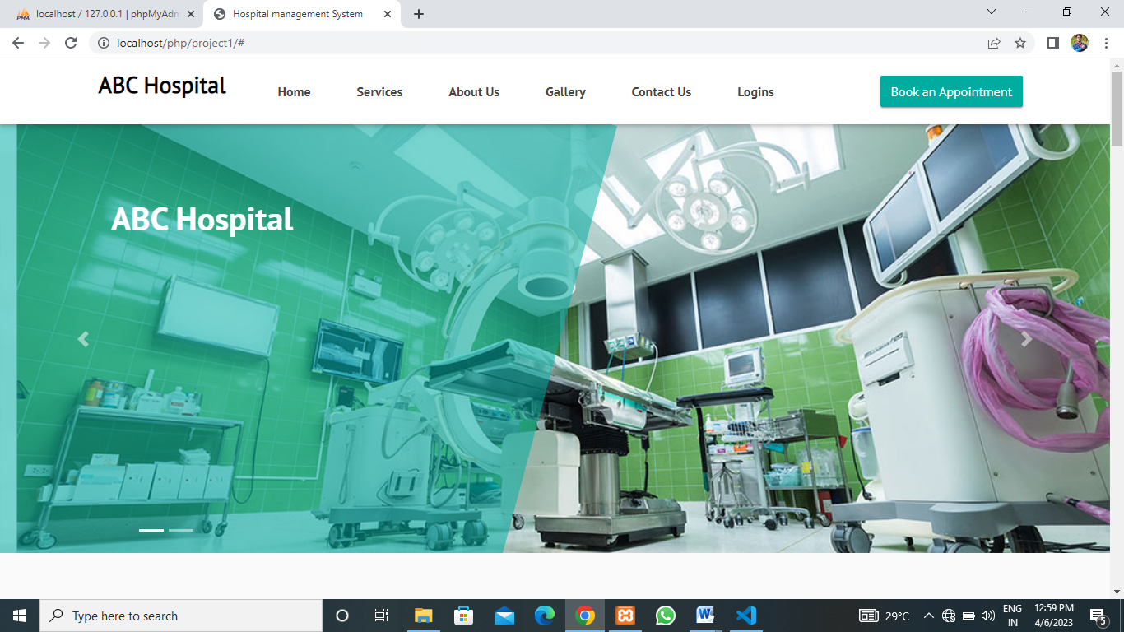Figure:1.1 Home page

**LOGIN PAGE**

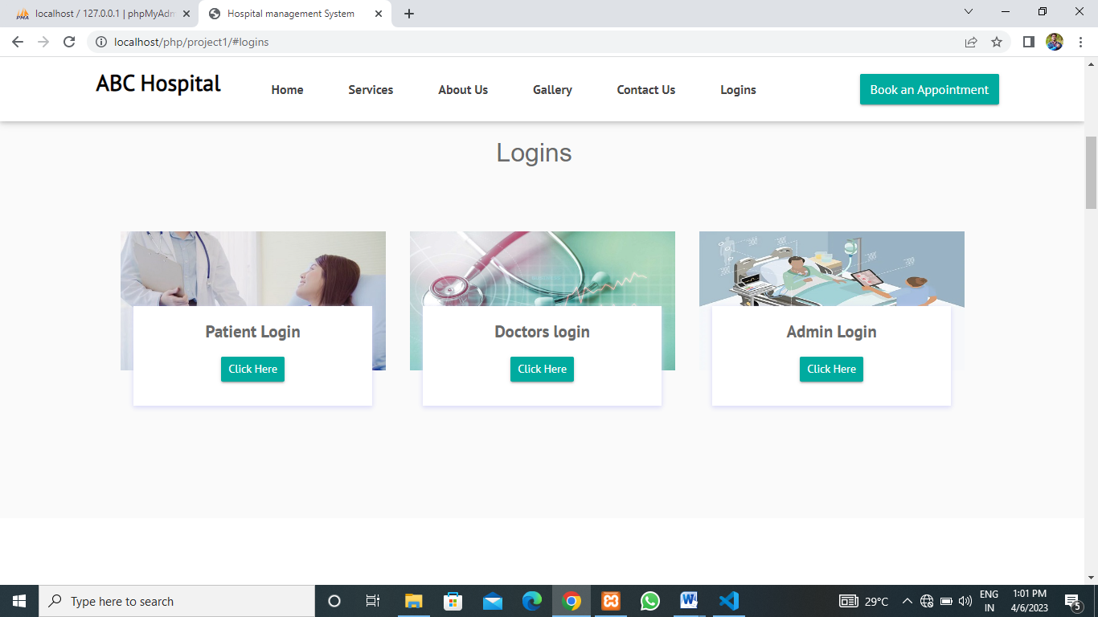

Figure:1.2 Login page

**ADMIN LOGIN**

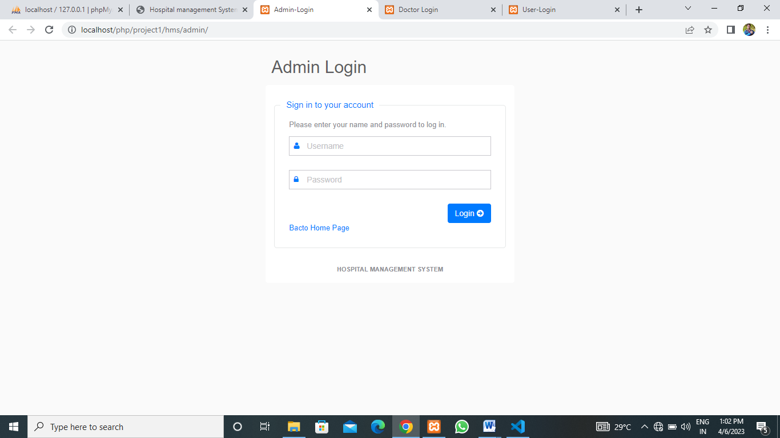

Figure:1.3 Admin login

**DOCTOR LOGIN**

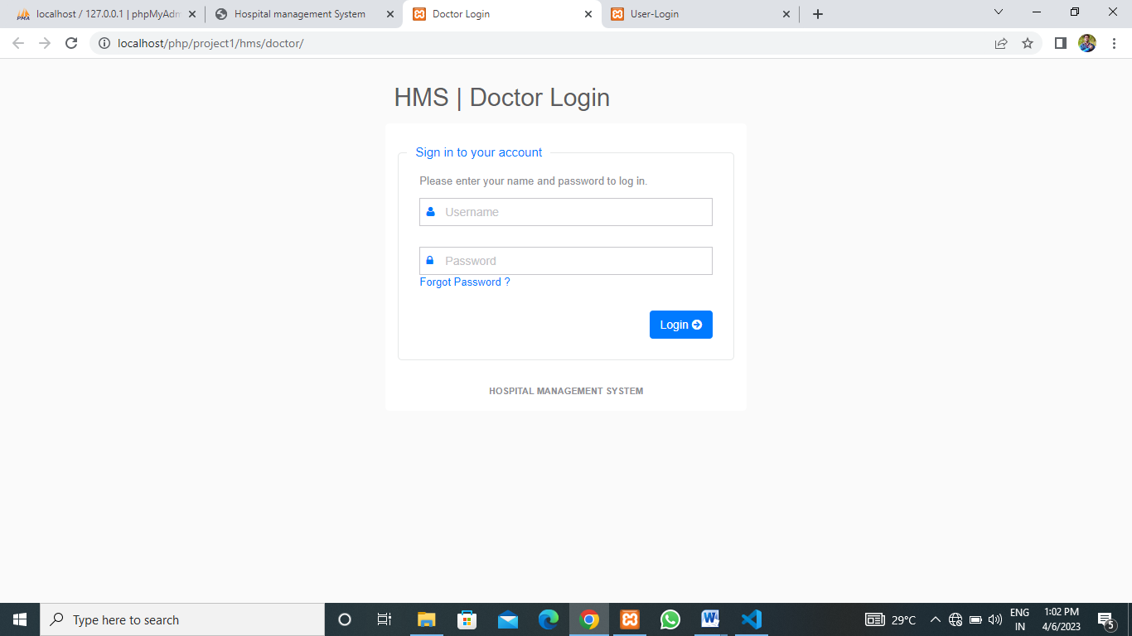

Figure:1.4 Doctor login

**PATIENT LOGIN**

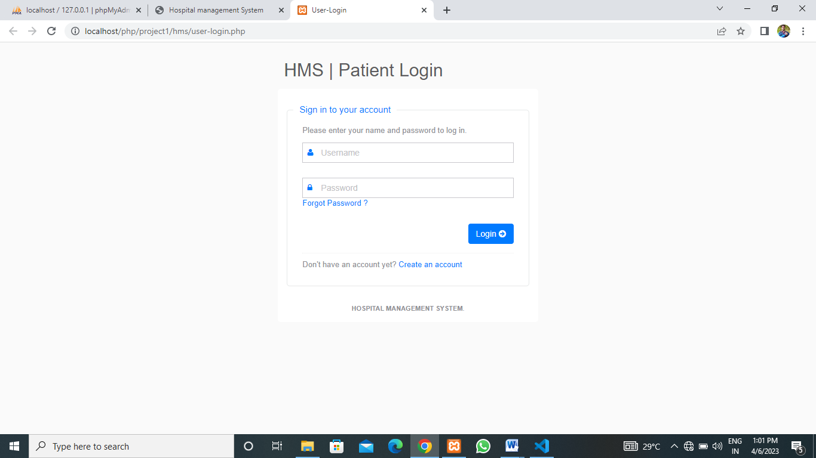

Figure:1.5 Patient login

**BOOK APPOINTMENT**

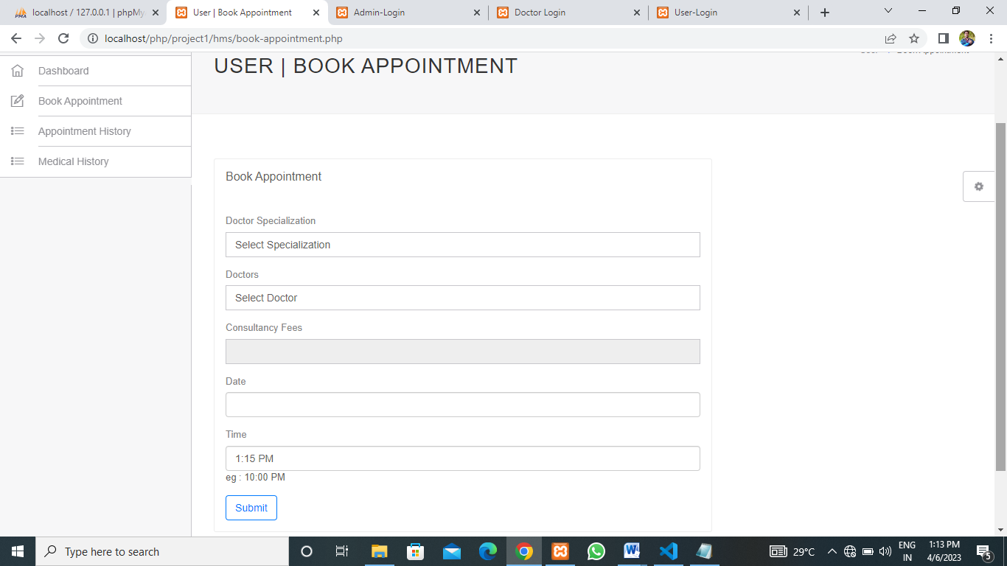

Figure:1.6 Book appointment

**INPUT FORM**

**PATIENT REGISTRATION**

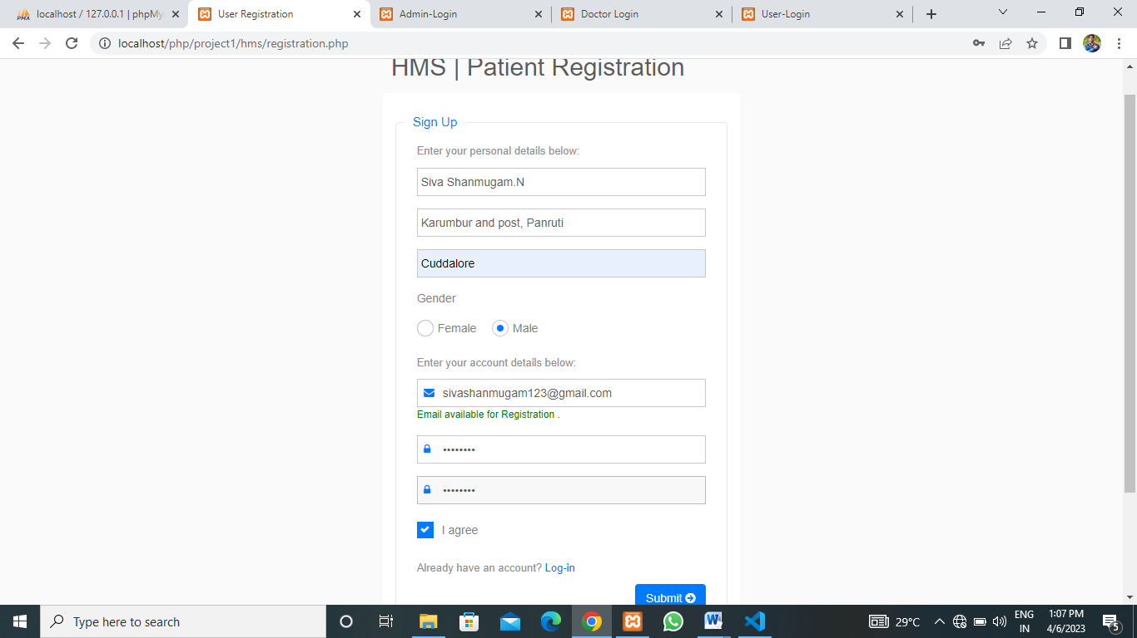

Figure:1.7 Patient registration

**DOCTOR LOGIN**

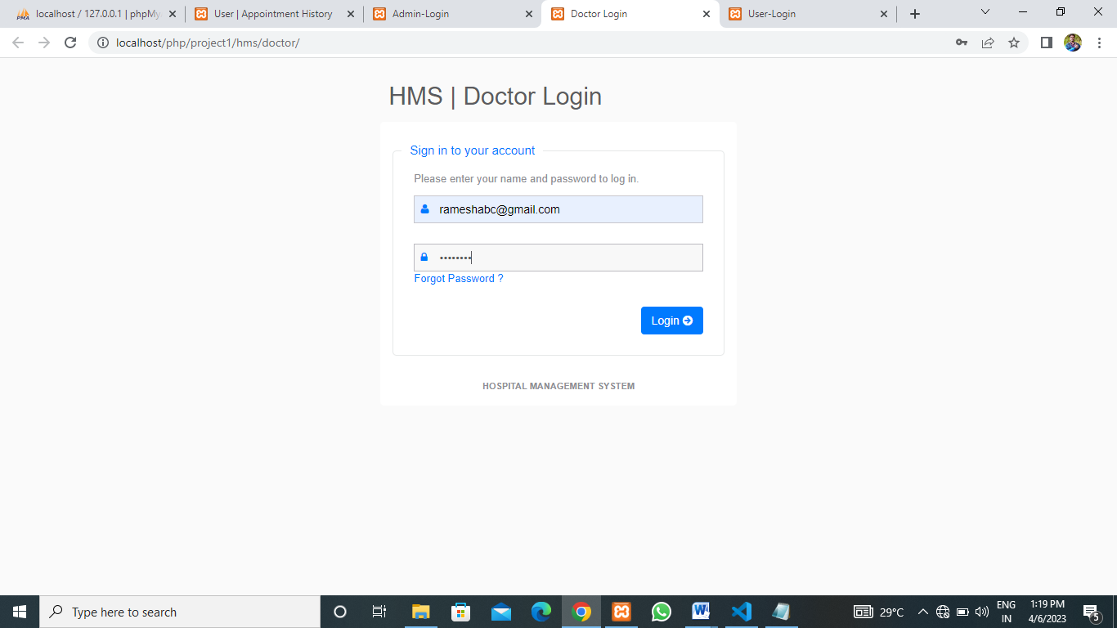

Figure:1.8 Doctor login

**DOCTOR ADD-PATIENT**

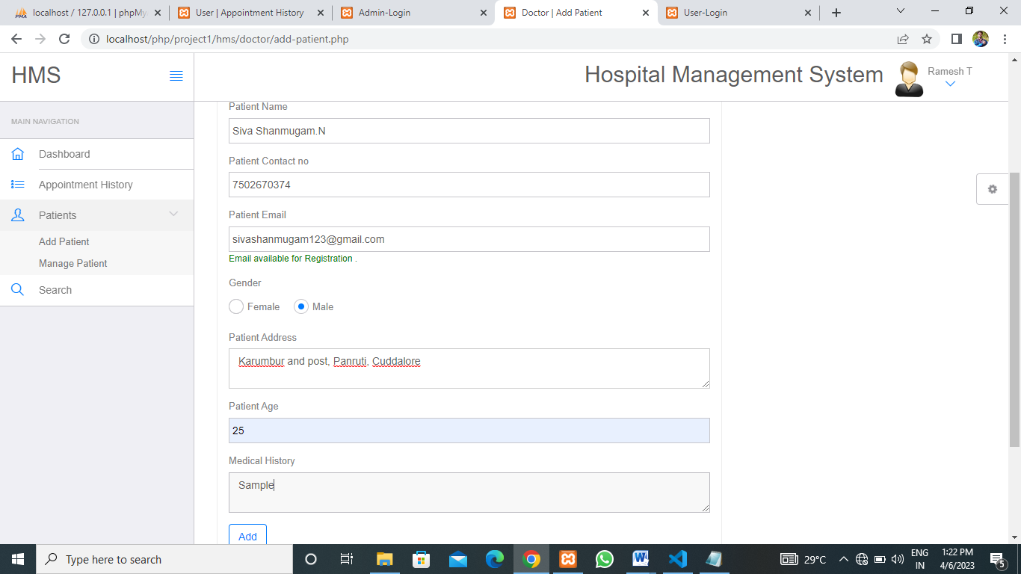

Figure:1.9 Doctor add-patient

**DOCTOR ADD-PATIENT MEDICAL HISTORY**

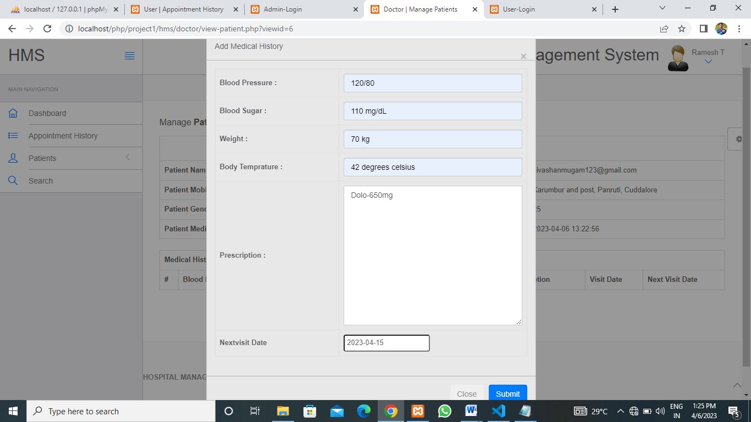

Figure:1.10 Doctor add-patient medical history

**ADMIN ADD-DOCTOR**

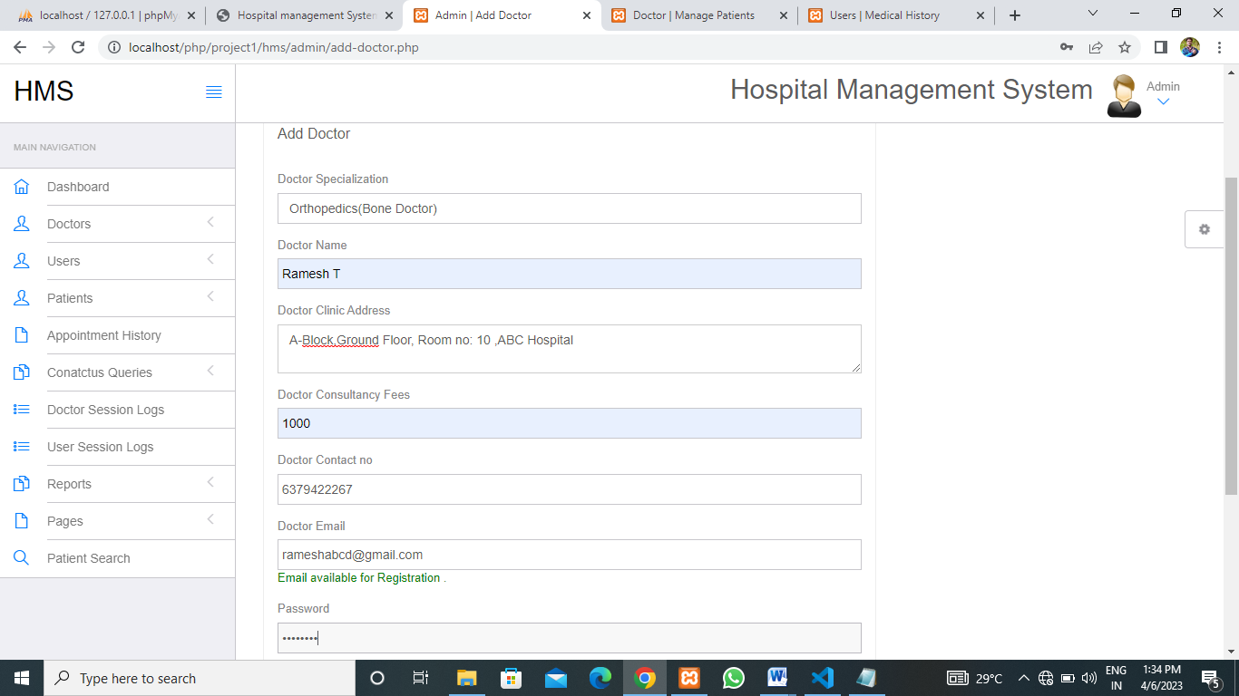

Figure:1.11 Admin add-doctor

**OUTPUT FORM**

**PATIENT APPOINTMENT-HISTORY**

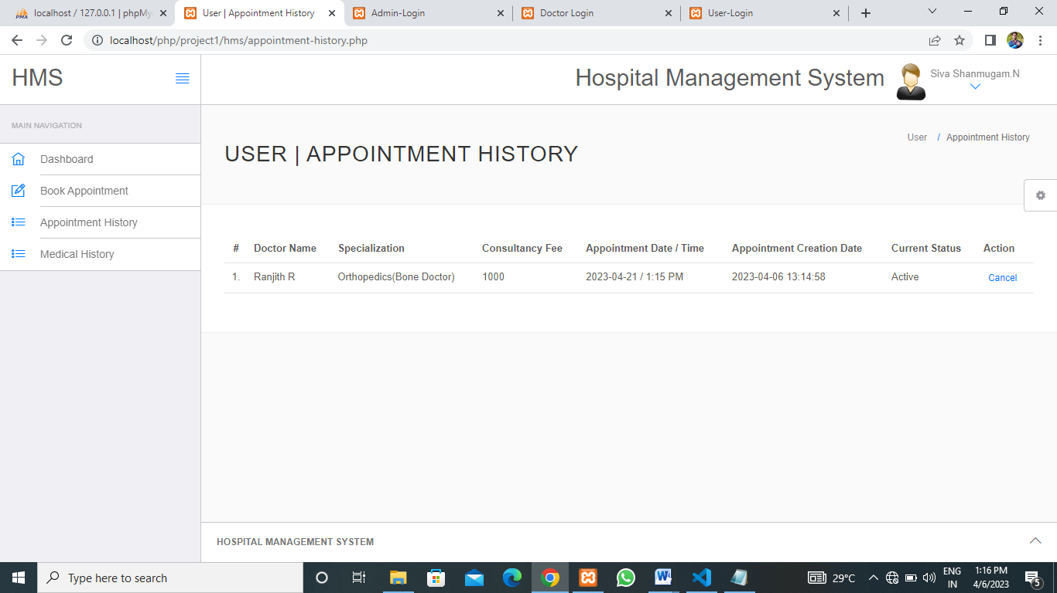 Figure:1.12 Patient appointment-history

**PATIENT MEDICAL-HISTORY**

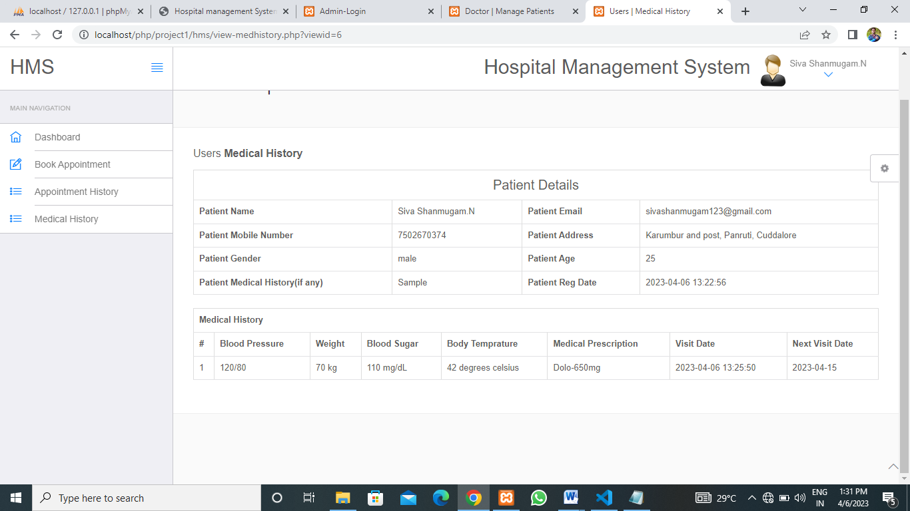 Figure:1.13 Patient medical-history

**DOCTOR SEARCH-PATIENT**

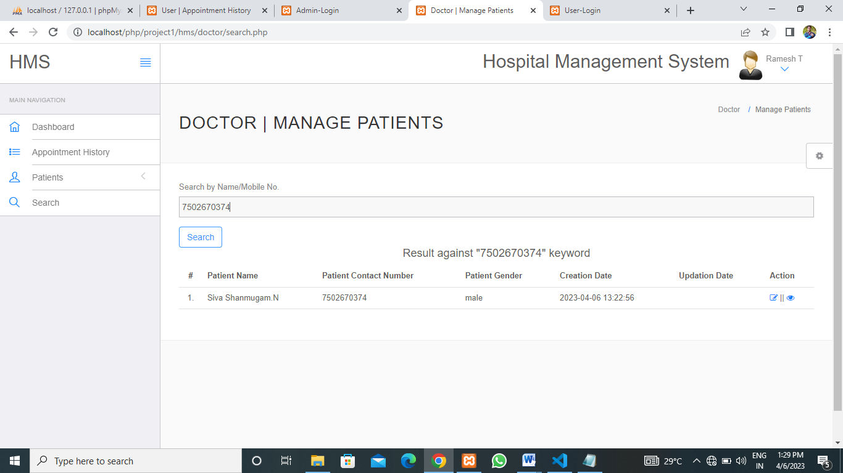

Figure:1.14 Doctor search-patient

**ADMIN VIEWS BETWEEN DATE REPORTS**

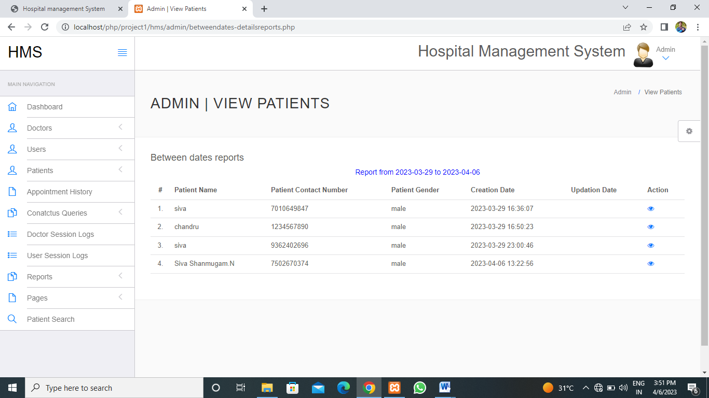

Figure:1.15 Admin view between date reports

**ADMIN VIEWS NEXTVISIT OF PATIENT**

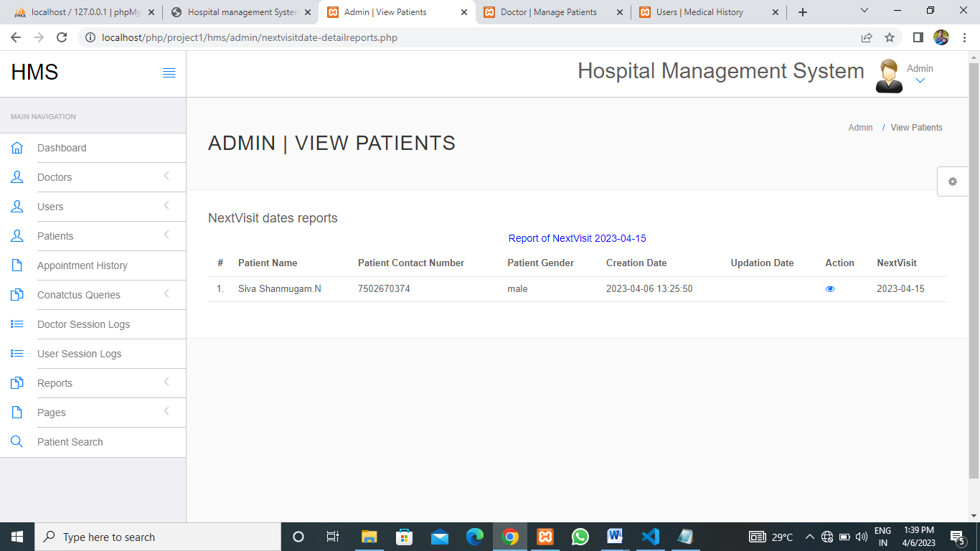

Figure:1.16 Admin view nextvisit of patient